Project Report: Automated Daily Data Scraping & Upload to AWS S3

1. Project Overview
This project is designed for automating financial data collection. The main objective is to automatically scrape MUFAP industry daily statistics and store them in an AWS S3 bucket. The goal is to make the data available daily without requiring manual downloads, ensuring it is ready for analysis at any time. The project uses AWS Lambda as the serverless computing environment to run the scraping and upload workflow automatically.

2. Architecture
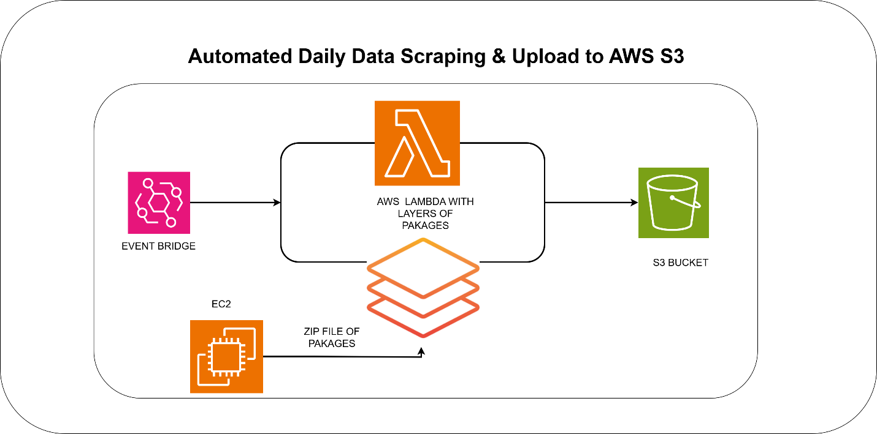

3. Tools & Technologies
The project uses Python for data scraping and processing. BeautifulSoup and Requests libraries are used for parsing web pages and extracting data. AWS Lambda is employed as a serverless function for automation, while AWS S3 is used for data storage. AWS EventBridge handles scheduling through cron jobs. AWS EC2 is used to create the Lambda deployment package with all required Python dependencies. The final data is stored in CSV formats, which are compatible with most analytics tools.

4. Workflow
The workflow consists of multiple steps. First, an EC2 instance is launched to prepare the Lambda deployment package. All necessary Python packages (like requests and beautifulsoup4) are installed on the EC2 instance, and the scraping script is zipped together with the dependencies. This zip file is then used to create a Lambda layer, which allows the Lambda function to access these packages in the AWS environment.
Next, a Python script running in Lambda sends a request to the MUFAP website and uses BeautifulSoup to parse the HTML and extract the required tables. The data is structured into dictionaries or lists for further processing. The data is then transformed into JSON or CSV format and validated to check for missing values, duplicates, and formatting issues.
AWS EventBridge is used to schedule the Lambda function. A cron expression triggers the Lambda function at the desired frequency—daily at midnight for regular automation or every minute for testing purposes. Finally, the Lambda function uploads the processed data to a specified folder in the S3 bucket using the boto3 library. Files are named using a consistent convention like mufap_data_YYYY-MM-DD.json.

5. Expected Outcome
The expected outcome of this project is that the latest daily industry statistics will always be available in the S3 bucket. Automation eliminates the need for manual data downloads and ensures that the data is structured and ready for analytics or reporting. Users can access fresh data reliably without any manual effort.

6. Conclusion
This project establishes a fully automated daily data pipeline from scraping to S3 storage, including the preparation of the Lambda deployment package via EC2. It ensures reliable, timely, and consistent availability of industry statistics while reducing manual effort and making data ready for immediate analysis.

